WEEK – 4

REST - Country Web Service

Nipuna

Superset id:6432842

Write a REST service that returns India country details in the earlier created spring learn application.  
  
**URL**: /country  
**Controller**: com.cognizant.spring-learn.controller.CountryController  
**Method Annotation**: @RequestMapping  
**Method Name**: getCountryIndia()  
**Method Implementation**: Load India bean from spring xml configuration and return  
**Sample Request**: http://localhost:8083/country  
**Sample Response**:

{

  "code": "IN",

  "name": "India"

}

SME to explain the following aspects:

* What happens in the controller method?
* How the bean is converted into JSON reponse?
* In network tab of developer tools show the HTTP header details received
* In postman click on "Headers" tab to view the HTTP header details received

Solution:

1) Country.java

**package** com.cognizant.springlearn.model;

**public** **class** Country {

**private** String code;

**private** String name;

**public** Country() {}

**public** String getCode() {

**return** code;

}

**public** **void** setCode(String code) {

**this**.code = code;

}

**public** String getName() {

**return** name;

}

**public** **void** setName(String name) {

**this**.name = name;

}

}

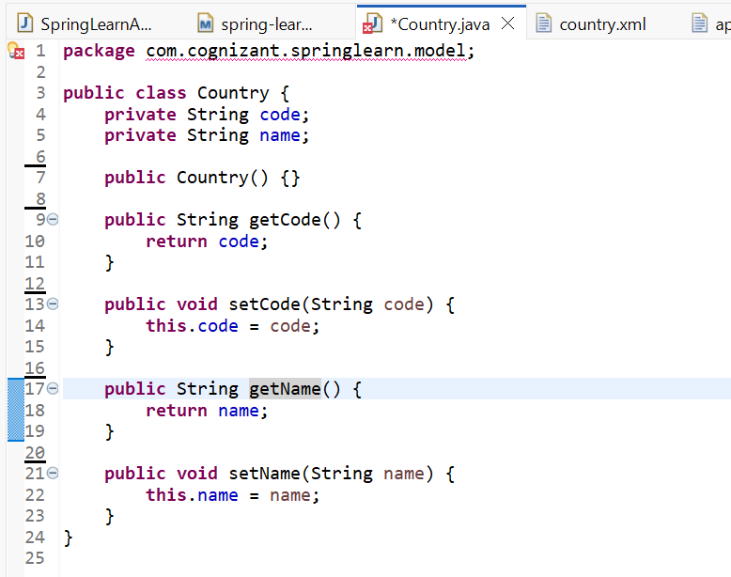

2) country.xml:

<beans xmlns="http://www.springframework.org/schema/beans"

xmlns:xsi="http://www.w3.org/2001/XMLSchema-instance"

xsi:schemaLocation="http://www.springframework.org/schema/beans

http://www.springframework.org/schema/beans/spring-beans.xsd">

<bean id="india" class="com.cognizant.springlearn.model.Country">

<property name="code" value="IN"/>

<property name="name" value="India"/>

</bean>

</beans>

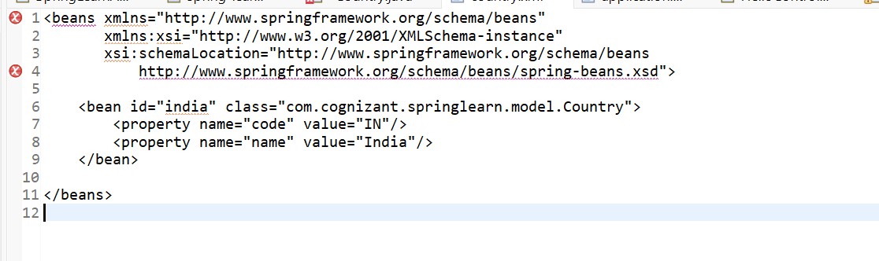

3) CountryController.java:

**package** com.cognizant.springlearn.controller;

**import** com.cognizant.springlearn.model.Country;

**import** org.springframework.context.ApplicationContext;

**import** org.springframework.context.support.ClassPathXmlApplicationContext;

**import** org.springframework.web.bind.annotation.RequestMapping;

**import** org.springframework.web.bind.annotation.RestController;

@RestController

**public** **class** CountryController {

@RequestMapping("/country")

**public** Country getCountryIndia() {

ApplicationContext context = **new** ClassPathXmlApplicationContext("country.xml");

**return** (Country) context.getBean("india");

}

}

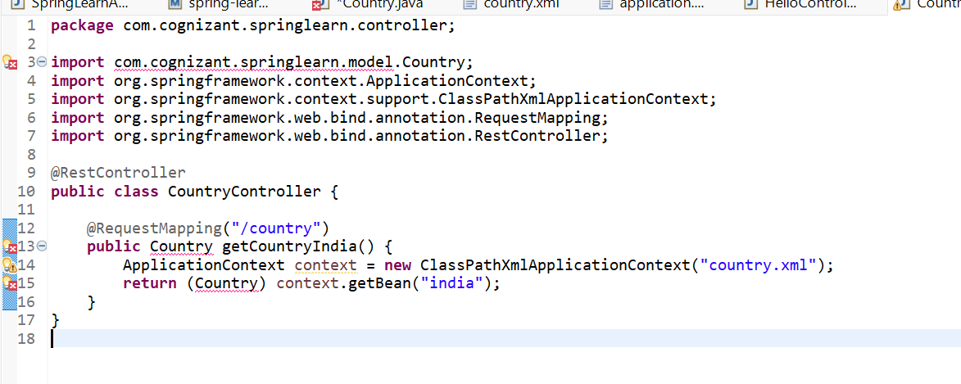

4) SpringLearnApplication.java:

**package** com.cognizant.springlearn;

**import** org.springframework.boot.SpringApplication;

**import** org.springframework.boot.autoconfigure.SpringBootApplication;

@SpringBootApplication

**public** **class** SpringLearnApplication {

**public** **static** **void** main(String[] args) {

SpringApplication.*run*(SpringLearnApplication.**class**, args);

}

}

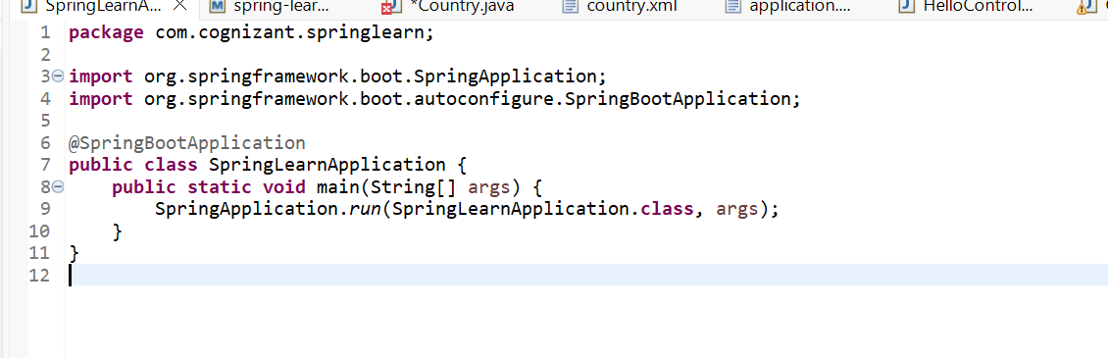

5) pom.xml

<project xmlns="http://maven.apache.org/POM/4.0.0"

xmlns:xsi="http://www.w3.org/2001/XMLSchema-instance"

xsi:schemaLocation="http://maven.apache.org/POM/4.0.0

https://maven.apache.org/xsd/maven-4.0.0.xsd">

<modelVersion>4.0.0</modelVersion>

<groupId>com.cognizant</groupId>

<artifactId>spring-learn</artifactId>

<version>0.0.1-SNAPSHOT</version>

<packaging>jar</packaging>

<name>spring-learn</name>

<description>Demo Spring Boot project</description>

<parent>

<groupId>org.springframework.boot</groupId>

<artifactId>spring-boot-starter-parent</artifactId>

<version>3.1.2</version> <!-- Use your Spring Boot version -->

<relativePath/> <!-- lookup parent from repository -->

</parent>

<properties>

<java.version>17</java.version> <!-- Use your JDK version -->

</properties>

<dependencies>

<!-- Spring Boot Starter Web for REST APIs -->

<dependency>

<groupId>org.springframework.boot</groupId>

<artifactId>spring-boot-starter-web</artifactId>

</dependency>

<!-- Optional: Spring Boot Starter Test for testing -->

<dependency>

<groupId>org.springframework.boot</groupId>

<artifactId>spring-boot-starter-test</artifactId>

<scope>test</scope>

</dependency>

</dependencies>

<build>

<plugins>

<!-- Spring Boot Maven Plugin -->

<plugin>

<groupId>org.springframework.boot</groupId>

<artifactId>spring-boot-maven-plugin</artifactId>

<version>3.1.2</version>

</plugin>

</plugins>

</build>

</project>

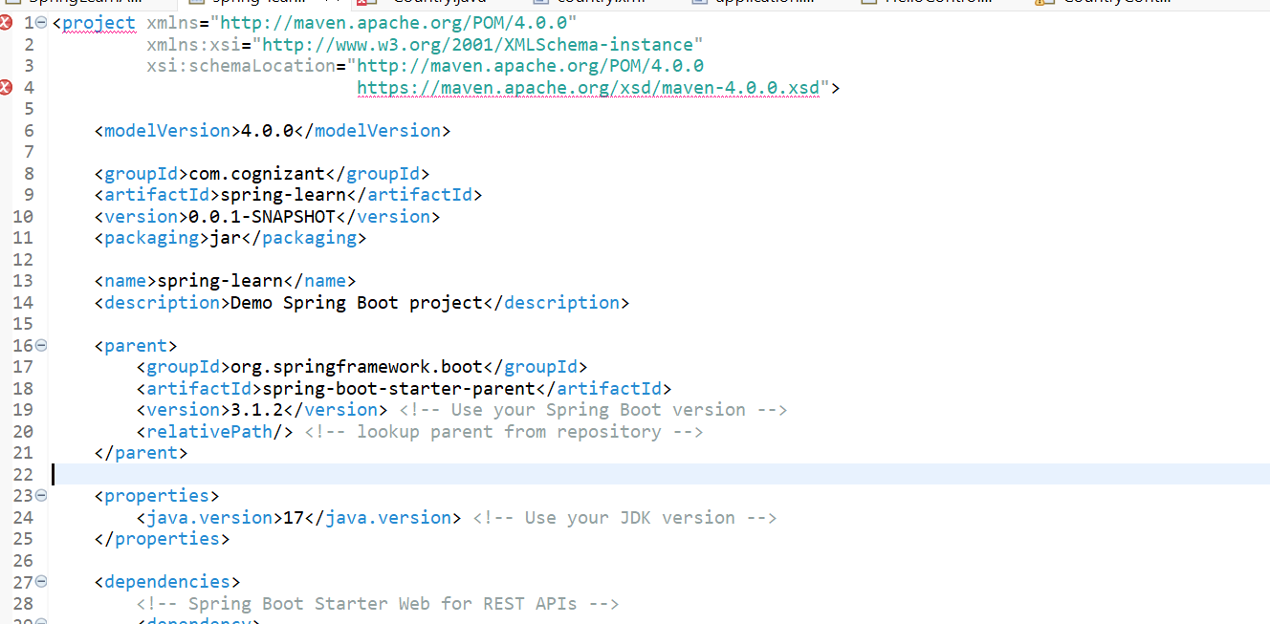

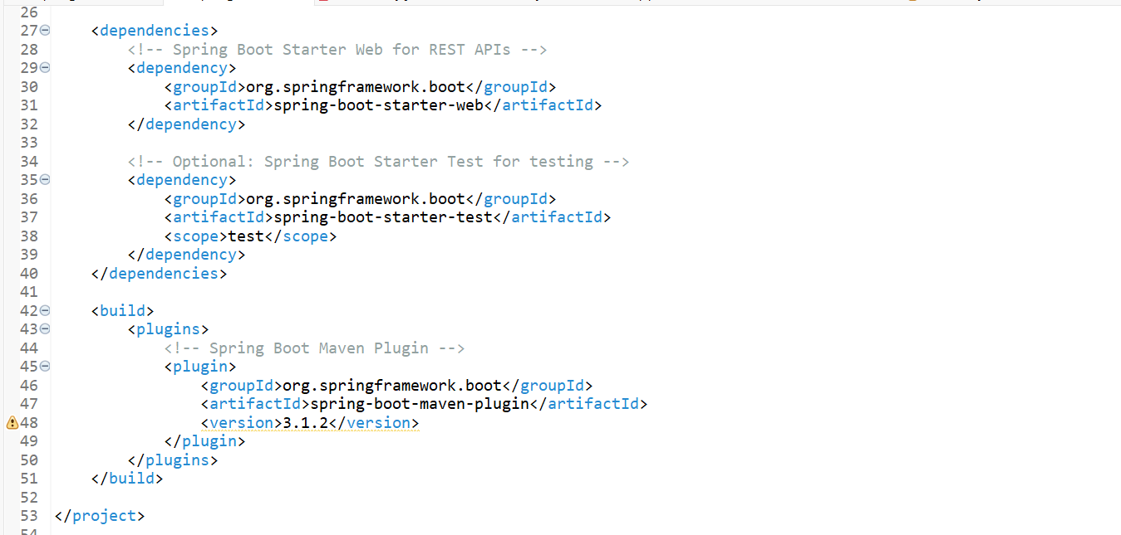

Output:

